|  |
| --- |
| CApgemini |
| Manifest Errors |
|  |
|  |
| |  |  | | --- | --- | | Project Code | 100488466 | | Project Name | Carter’s Managed Services | |
| |  |  |  | | --- | --- | --- | | Prepared/Modified by | Role | Date of Preparation | | HussainBasha Pathan | Team Member | 12/27/2016 | | Reviewed by | Role | Date of Review | | Rakesh Kumar | Team lead |  | | Approved by | Role | Date of Approval | | Sabita Prasad | Project Lead |  | | Circulation List | WMS Team |  | | Version Number | 1.0 |  | |

|  |
| --- |
|  |

***Manifest Errors***

**Issue Description:** User is receiving error while manifesting oLPN.

**Severity:** High

**Description:** User is unable to manifest the oLPN due to various errors as below:

1. Destination Contact Name is required for order 1213482053

2. Error inserting record into database.

3. International Goods Description required for Order 1213516673

4. Matching tariff rate zone mapping for this O/D pair not found.

5. Invalid Order Status

6. Ship_via has (0) requested and Ship Date is (1)

7. Failed to assign oLPN to shipment.

8. Consolidator Contact Name is required for Order 1219343311.

9. LPN 00000197181573692313 does not have retail route number. Cannot continue.

10. oLPN is associated with TL/LTL shipment and cannot be manifested. Do you want to weigh it.

**Mitigation Approach:**

**Scenario 1:**

**Issue Description:** User receives an error on oLPN saying below:

**Error:** Destination Contact Name is required for order 1213482053

Attached is the reference mail for the same issue.



**Resolution:**

**Step 1:** Request userGo to‘UI-> Weigh and Manifest oLPN’,enter the

oLPN number and click on‘next’ button at the bottom.

**Step 2:** Then click on‘Edit DO Destination Information’and request user to

provide the correct customer name here while manifesting the carton.



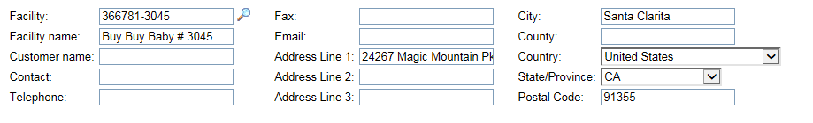

**Scenario 2:** User receives a below error while manifesting the oLPN.

**Error:** Error inserting record into database.

Attached is the reference mail for the same issue.



**Reason:** This happens when there is a bad update on the FedEx Server.  We

have to remove the carton from FedEx by manifesting to UPS Ground,

then de-manifest oLPN and re-manifest to FedEx in which WM will

request a new tracking number from the FedEx Server.

**Resolution:**

**Step1:** Manifest the oLPN first to “UPS GROUND WHOLESALE” and then

De-Manifest the carton.

**Step 2:** Then Re-Manifest oLPN to “FEDEX GROUND COLLECT”.

**Note:** Always request the user print a new Shipping Label once the

oLPN is manifested.

**Scenario 3:** User receives a below error while manifesting the carton:

**Error:** International Goods Description required for Order 1213516673

Attached is the reference mail for the same issue.



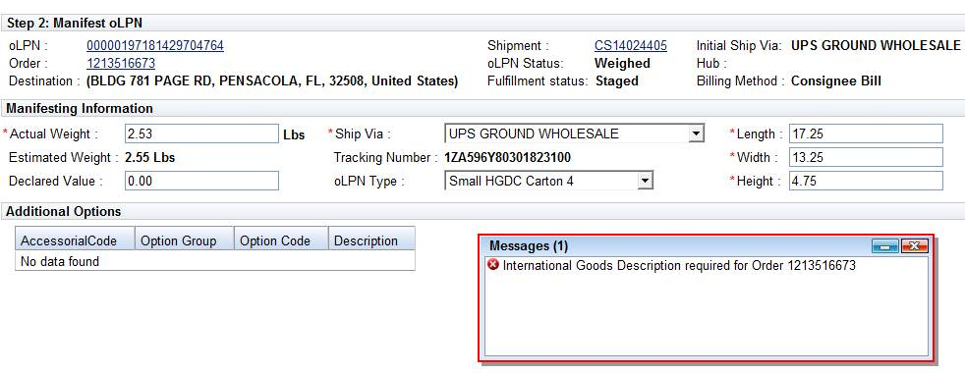

**Resolution Steps:**

**Step1:** Check the address on the order; if it is international we can’t do

anything as WM is not configured for international parcel.

**Step 2:** Confirm with user address on the shipment and address on the cartons is

same or not.

Then follow the below steps to manifest:

1. Go to Manual Load Planning
2. Find Shipment
3. Remove Order/LPN from Shipment
4. Add Order/LPN to “NEW” Shipment
5. Save Workspace
6. Go to Manifest oLPN screen select “Edit DO Destination”
7. Enter in Correct Address
8. Click Save
9. Note – WM caches some values, so return to oLPN Screen
10. Enter oLPN
11. Select oLPN > Weight/Freight Manifest
12. Enter in Weight
13. Manifest
14. Print new Shipping Label

**Reason:** We need to follow the above steps because the LPN was on a shipment

that already had manifested LPN’s, we have to move the oLPN to a

new shipment in order to change the Address.

**Note:** Always request user to print a new Shipping Label once the

oLPN is manifested.

**Scenario 4:** User receives a below error while manifesting the carton:

**Error:** Matching tariff rate zone mapping for this O/D pair not found.

Attached is the reference mail for the same issue.



**Reason:** This was due to invalid postal code on the order.

**Resolution Steps:**

**Step 1:** Request userGo to‘UI-> Weigh and Manifest oLPN’,enter the

oLPN number and click on‘next’ button at the bottom.

**Step 2:** Then click on‘Edit DO Destination Information’and enter the correct

postal code here and manifesting the oLPN.





**Note:** Always request user to print a new Shipping Label once the

oLPN is manifested.

**Scenario 5:** User receives a below error while manifesting the carton:

**Error:** Invalid Order Status

Attached is the reference mail for the same issue.



**Reason:** This was due to order was in 170 (Manifested) status and oLPN was in

30 (Weighed) status.

**Resolution Steps:**

**Step 1:** Update the order status to 160 (Weighed) using below sql:

Update orders set do_status = '160' where tc_order_id='1213883969';

**Step 2:** Try to manifest the carton. If you get an error ‘Error inserting a record into database’ while manifesting the carton then follow below steps to correct it:

1. Go to oLPNs
2. Select LPN > Weight / Manifest
3. Change Ship Via to UPS Ground Wholesale
4. Manifest
5. Goto Manifest UI
6. Find Manifest > De-Manifest Carton
7. Go back to Weight / Manifest screen
8. Change Ship via back to FedEx Ground Collect
9. Manifest Carton

**Note:** Always request user to print a new Shipping Label once the

oLPN is manifested.

**Scenario 6:** User receives below error on cartons when they try to Edit DO destination during manifest

**Error Message:** Ship Via has (0) requested and Ship Date is (1)

Attached is the reference mail for the same.



**Reason:** This was an issue with pick-up and delivery **dates** Both were same date, which left no time for transit.

**Resolution Steps:**

1. Update the dates, then built new shipments.
2. Assign Ship Via to FedEx.
3. Change the address same as User given
4. Then manifest it.

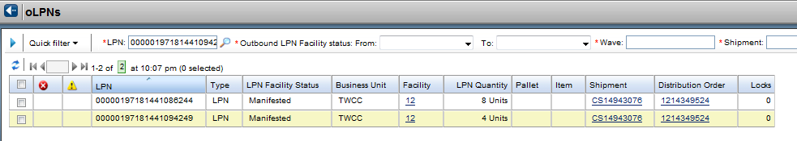

**Note:** Always request user to print a new Shipping Label once the

oLPN is manifested.

**Scenario 7:** User receives below error on carton while manifesting cartons

**Error Message:** Failed to assign oLPN to shipment.

Attached is the reference mail for the same.



**Reason:** This is an issue with incorrect Order Destination Address like we can see in below Screen Shots of different address for one Postal Code.

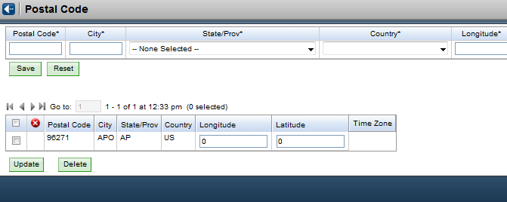

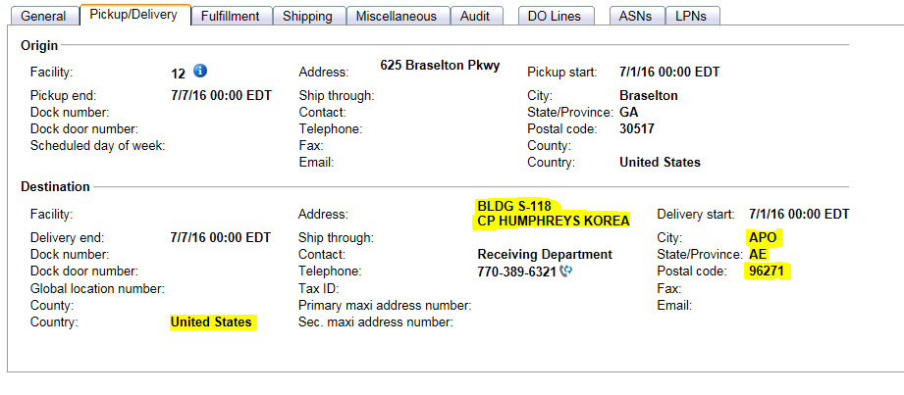

**Resolution Steps:**

**1.** Check the carton status. Should be Weighed (30).

**2.** Need to do Manual load planning and manifest oLPNs one by one.

If still it is not manifesting getting same Error Message “Failed to assign

oLPN to shipment” then might be error with Order Destination Address.

**3.** Check the status of oLPN. Need to know if the postal code is 96271 then

What is the City, State/Province for this Postal code as shown in below.

To check the correct address

Goto UI🡪Postal Code



**Note**: Every city, State/Province, zip combination on distribution orders is compared to postal codes UI (Database table).

**4.** Update the order to the correct address.

**5.** After then ‘Manifest’ the oLPN.

**Scenario 8:**

**Issue Description:** User receives an error on oLPN saying below:

**Error:** Consolidator Contact Name is required for Order 1219343311.

**Resolution:** Run the CCF Below and try manifesting through UI.

Update orders

      set plan_d_facility_alias_id  = NULL

      where orders.acct_rcvbl_acct_nbr = '366781'

      and orders.do_status < '170';

**Scenario 9:**

**Issue Description:** User receives an error on oLPN saying below:

**Error:** LPN 00000197181573692313 does not have retail route number. Cannot continue.

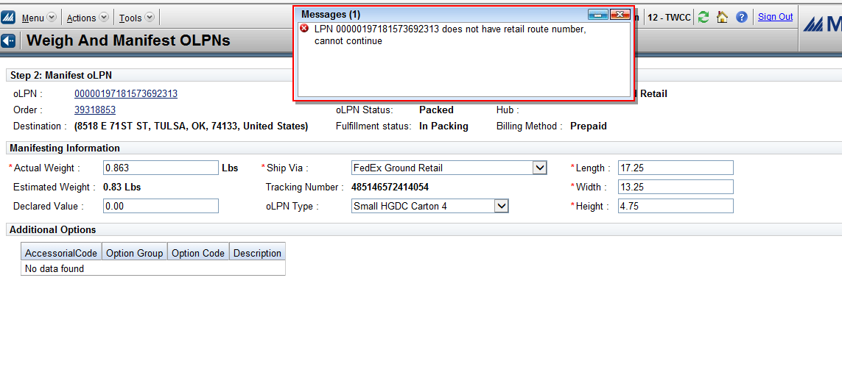

**Resolution:**

We need to perform assign route for that particular carton.

1. Log in to RF
2. CTRL-F and type function “Assign route” and press enter.

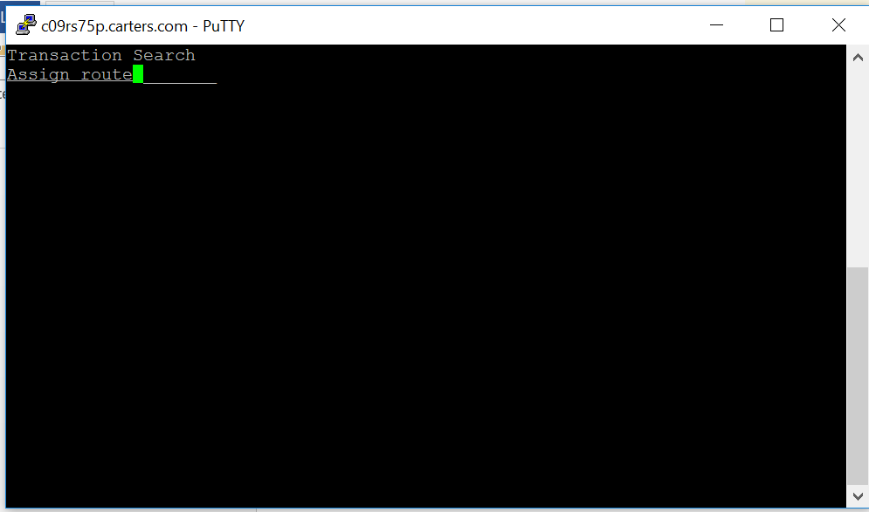

1. Select the option “Assign route” and enter the Route ID (eg: FXGR)

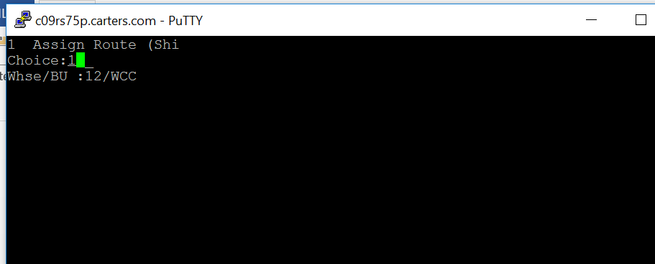

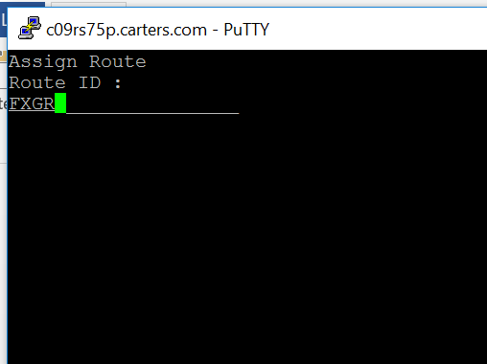

1. Enter the oLPN and press enter.

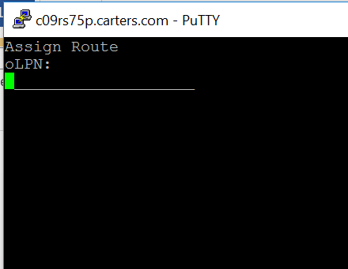

1. Go to DC12 UI “Weigh and manifest” and try manifesting the carton

**Scenario 10:**

**Issue Description:** User receives an error on oLPN saying below:

**Error:** oLPN is associated with TL/LTL shipment and cannot be manifested. Do you want to weigh it?

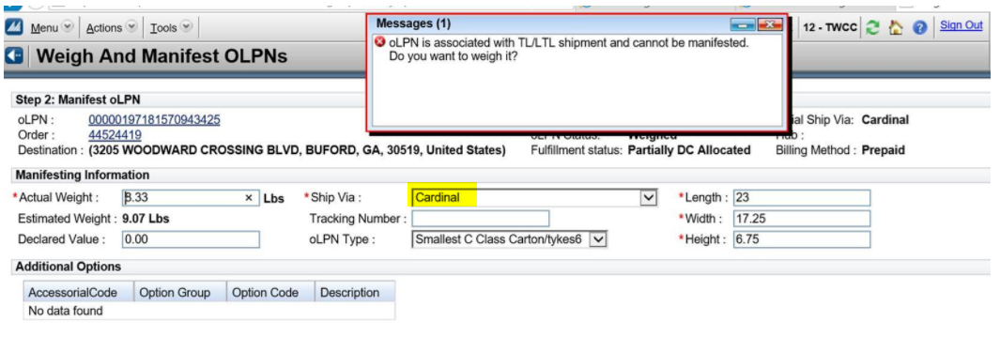

**Resolution:**

If the Ship_via for that carton is ‘CARDINAL’, we cannot manifest cardinal as it is an LTL service.

We need to inform the operator that the carton for that particular store is ‘CARDIANL’ and should not be manifested.